**Wheels For Money**

**Description:**

Wheels For Money is a web application. This application is used for selling, leasing, retailing, vehicle service and rating the vehicle. WFM is also targeting the customer and merchant relationship and service. Where merchant can use this website to sell or rent vehicle to the customer directly from this application.

Technology Used:

* HTML
* CSS
* Java Script
* React Js

IDE’s

* Vs Code

**How structure is prepared:**

Here we have designed login page, sign-up page and forgot password page for the user.

Login Page:

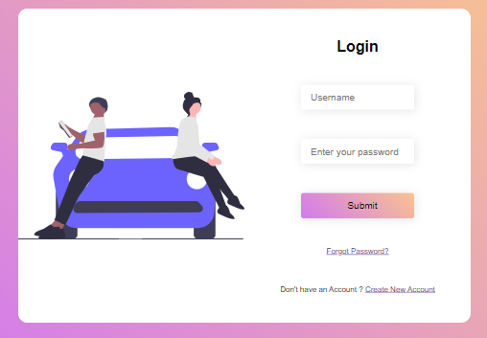

In login page user has to enter their username/email-id and their respective password to login their page. Once he login their page it will directly open the home page with their user-name showing on the top most right corner.

Forgot Password Page:

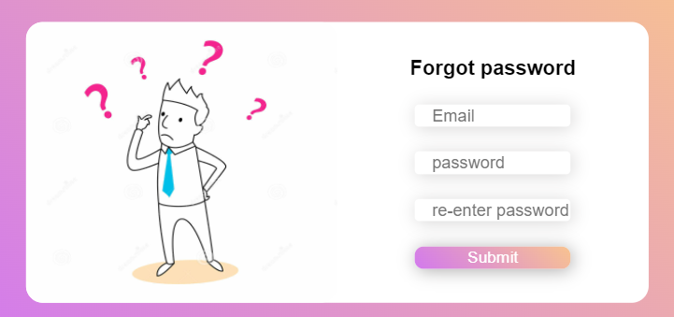

If the user forgot their password, they can reset their password through forgot password page. Here they have to enter their email-id through which they have registered their account and then enter the new password and confirm their new password and then submit.

Sign-up Page:

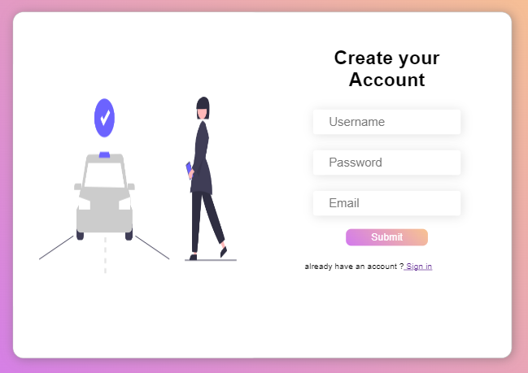

If the user doesn’t have any account, they can create their own account through sign-up page. In this page, they have to fill their username, password and email-id for creating their own account for this page.

**Validation Done:**

*npm:* It stands for “Node Package Manager” npm is the package manager for the Node JavaScript platform.

*nmp start:* It is a command used to run the server.

*react-router-dom:* It is a npm package that enables us to implement dynamic routing in a web app. It allows us to display pages and allow users to navigate them. It is a fully-featured client and server-side routing library for React. We use “npm install react-router-dom” to install in react application.

*Router:* React Router is a standard library for routing in React. It enables the navigation among views of various components in a React Application, allows changing the browser URL, and keeps the UI in sync with the URL.

*useState*: It is a type of react hook which allows us to track state in a function component.

*useHistory:* This is one of the most popular hooks provided by React Router. It lets you access the history instance used by React Router. Using the history instance, we can redirect users to another page.

*axios:* It is a third-party library that serves to create **HTTP** requests that are present externally. It helps in fetching the data from the third-party server(backend).

**Functionality of the Page:**

*If Success:* If the user login successfully, it directly goes to another page as home page.

*If wrong password:* if the user enters the wrong password, it will show the message as wrong password entered.

*If already present:* If the user is already present in the database while doing the sign-up process, it will show the username/email-id already exists.